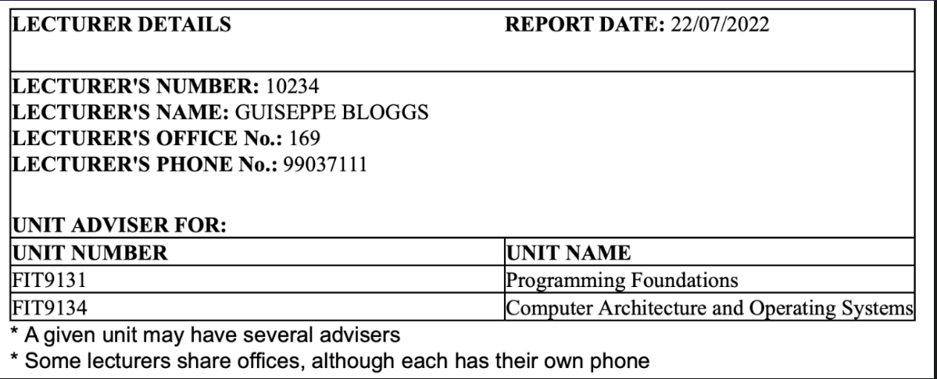

**UNF**LECTURER(lect_no, lect_name, lect_office, lect_phone (unit_no, unit_name))  
  
**1NF**LECTURER(lect_no, lect_name, lect_office, lect_phone, unit_no)  
Advise_unit(unit_no, unit_name, lect_no)  
- Many cardinality relation will contain the PK of the 1 cardinality relation  
- When there is a multivalued attributed such as above example, then we need to create a table with both primary keys

**CK**lect_no  
lect_phone  
  
ADVICE_UNIT(lect_no, unit_no, unit_name)  
  
CK: lect_no, unit_no  
PK: lect_no, unit_no  
 **PD:**unit_no _> unit_name **2NF  
LECTURER(**lect_no**,** lect_name, lect_office, lect_phone) **ADVICE**(lect_no, unit_no)  
**UNIT**(unit_no, unit_name) **TD**NONEIf there are any CK attributes then we don’t consider them for transitive **3NF  
LECTURER(**lect_no**,** lect_name, lect_office, lect_phone) **ADVICE**(lect_no, unit_no)  
**UNIT**(unit_no, unit_name)  
  
**Full Dependencies**